# Game Design Documentation

## 3.1 Concept

The player needs to get the character from one side of the map to the other to complete the level. The player also controls the character in both 2 dimensional and 3 dimensional spaces to allow them to solve puzzles. The character has the ability to move certain objects such as a box to get to areas of the map.

## 3.2 Gameplay

The player is required to navigate from the left to the right and get to the other castle at the end of the map. The player is required to navigate through 2D and 3D environments and complete puzzles along the way. The player is limited to different actions in each view.

## 3.3 Player Objective

Solve puzzles and get to the other side of the level.

* Learn to Move
* Learn to Control Camera Modes
* Learn to Jump
* Push Objects
* Use the Kinect head tracking

## 3.4 Core Gameplay Mechanics

*Player Character Abilities*

* Jump
* Push
* 2D Movement
* 3D Movement

*Enemy Character Abilities*

* Search Radius
* Throw Weapon

## 3.5 Camera

This game uses both the orthographic and the perspective camera modes. Orthographic mode is used to display 2D area and perspective is used for both 3D views. The 2D and 3D camera follow the character thought the game play and uses a zoom function to zoom into the character when not moving. The Kinect will also control one of the 3D cameras by tracking the players head movement.

## 3.6 Controls

Both the keyboard and Xbox 360 controller can be used to control the game. (Use of the Xbox controller is advised)

|  |  |  |
| --- | --- | --- |
| Player Action | Button | Keyboard |
| Move | Left Analog Stick | WASD |
| Jump | A Button | Space Bar |
| Long Jump | X Button | X |
| Push | B Button | Z |
| 3D Camera | Left Shoulder Button | V |
| Kinect Camera | Right Shoulder Button | B |
| 2D View | Y Button | C |

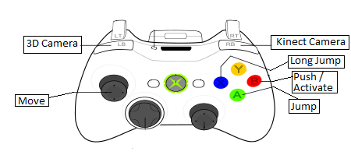

**Figure 2 – Game Controller**

## 3.7 Characters

## 

**Figure1 – Barr (Main Character) Figure2 – Cletus (Enemy) Figure3 – Follower (Enemy).**

Two Characters have been designed with added animation for triggered sequences Figure 1 and Figure 2. Barr from fig. 1 is the main character in the game and triggers movement animation such as walk, run and jump. (These can be found in the Inspector in the Player Object)

Cletus from fig. 2 is triggered at a certain moment in the game and animation such as throw, run and jump are also assigned.

Follower form fig. 3 watches an area around the model and once the player enters the area the model moves towards the player. If a collision is detected between the model and the player, the players’ lives counter decrements.

## 3.8 Game Objects

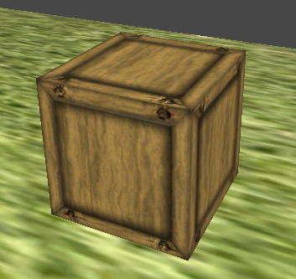 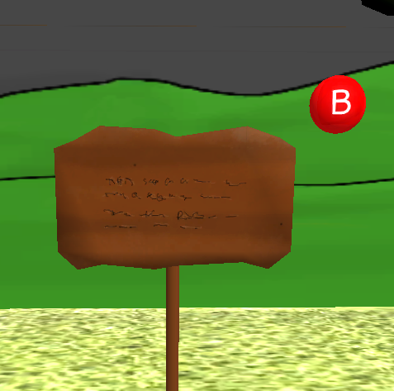 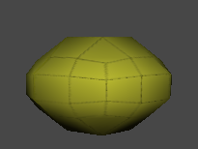

**Figure 4 – Box (2D & 3D Control) Figure 5 – Sign (Text Display) Figure 6 – Orb (Time Ext).**

Fig. 4 is a box that can only be moved in the 2D camera mode. The box can be customized in the Inspector to enable 2D and 3D modes. The 3D mode available moves the box into the background when 3D is enabled.

Fig. 5 is a sign for tutorial mode, this is used in the Demo to explain how the game works and can be customized by altering the path to the texture in the Inspector.

Fig. 6 is an orb to increase the Players time limit in 3D. Once the player collides with the object a partial effect is triggered and 2 seconds is added to the Player’s time by default.

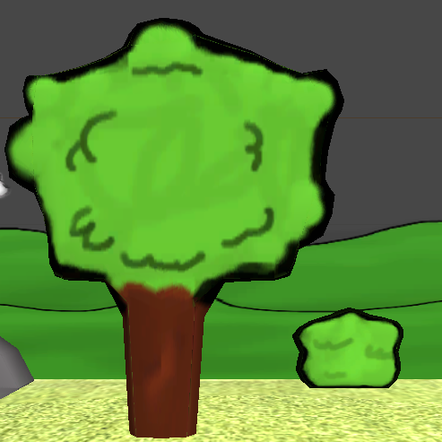 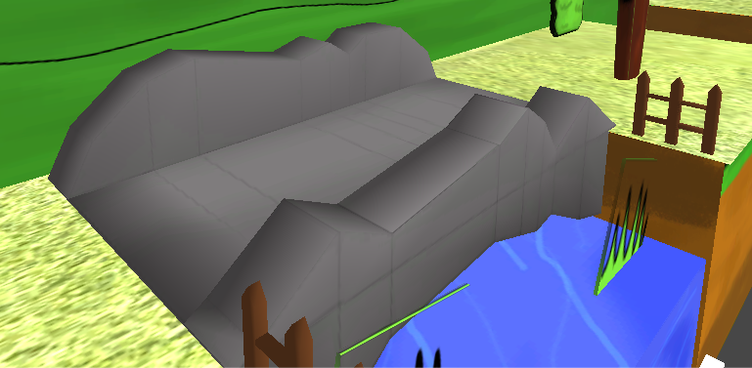

**Figure 7 – Tree & Bush Figure 8 – Bridge (3D Bridge Puzzle)**

Fig. 7 is an example of trees and bushes added to the games assets catalogue to create an aesthetic looking game.

Fig. 8 is another example of aesthetic models that have been added to the game and the bridge is also a part of an in game puzzle.

## 3.9 Assets

List of all classes used in the game. This document has evolved through development as the need for code changed.

|  |  |  |  |  |
| --- | --- | --- | --- | --- |
| CODE | Name | Description | Complete | File Type |
| AI | CletusAnim | TrigersPlayerAnimation | Yes | .cs |
|  | ControlMatch | ControlBattleTime | Yes | .cs |
|  | SpearAI | ControlsSpearTracking | Yes | .cs |
|  | TrackPlayer | ReturnsPlayerCordinates | Yes | .cs |
| Follower | FollowerDamage | CollideWithPlayerDecrementLife | Yes | .cs |
|  | FollowerDestroy | CollideWithPlayerDestroyObject | Yes | .cs |
|  | FollowPlayer | MoveTowardsPlayer | Yes | .cs |
| Backdrop | MoveBackground | ParallaxBackground | Yes | .cs |
| BoxMov.. | Box2D3D | MoveBoxInCameraMode | Yes | .cs |
|  | BoxCollisionDetector | BoxMovementDirection | Yes | .cs |
|  | WoodenBox | WoodenBoxProperties | Yes | .cs |
| Camera | Camera2D | 2DCameraSettings | Yes | .cs |
|  | Camera3D1 | 3DCameraSettings | Yes | .cs |
|  | StationaryCam | HoldCameraPositionIn2D | Yes | .cs |
|  | CameraListener | ControlsCameraSelection | Yes | .cs |
| Character.. | CharAnimRot | TriggerBossAnimation | Yes | .cs |
|  | CharController2D | 2DControlProperties | Yes | .cs |
|  | CharController3D | Generic3DControlProperties | Yes | .cs |
|  | CharController3D1 | Specific3D1ControlProperties | Yes | .cs |
|  | CharController3D2 | SpecificKinectControlProperties | Yes | .cs |
|  | CurrentGround | ReturnsCharacterContactGround | Yes | .cs |
| GUI | MainMenu | MainMenuProperties | Yes | .cs |
| Kinect | ControlKinectFloor | Hide/DisplayEventFloor | Yes | .cs |
|  | HeadMonitor | StoreUser’sHeadLocation | Yes | .cs |
|  | KinectCameraContoller | ModifyKinectValuesForCamera | Yes | .cs |
|  | ViewTrigger | TriggerEventFromHeadLocation | Yes | .cs |
| LevelTrig.. | BossScene1 | PauseControlPlayMessage | Yes | .cs |
|  | BridgeLever | TriggerEventPlayAnimation | Yes | .cs |
|  | ButtonEvent | TriggerEventFromButton | Yes | .cs |
|  | DestroyParticle | DestroyParticleAfter5Seconds | Yes | .cs |
|  | InvisWall | PlayerPassWallBecomesSolid | Yes | .cs |
|  | KillFloor | PlayerCollisionTriggerRespawn | Yes | .cs |
|  | RockRoll | TriggerRockRollingEvent | Yes | .cs |
|  | RockTrigger | TriggerEventStartRockRoll | Yes | .cs |
|  | SignCalls | DisplaySign | Yes | .cs |
|  | SignTextDisplay | DisplayAssignedTexture | Yes | .cs |
|  | TextDisplay | ControlTextDisplayEvent | Yes | .cs |
|  | timeCollection | AddTimeTo3DTimeLimit | Yes | .cs |
|  | WaterFallTrigger | PlayerTriggerEventInWaterfall | Yes | .cs |
| CheckPo.. | CheckPointLives | CheckPointArea-Respawn | Yes | .cs |
|  | CheckTrigger | ManuallySetCheckpoint | Yes | .cs |

|  |  |  |  |  |
| --- | --- | --- | --- | --- |
|  | Name | Description | Complete | File Type |
| Design | DesignDocument | ContainsInformationOnDesign | Yes | .docx |
|  | Level1.9 | DemoScene | Yes | .unity |
|  | Menu1.0 | MainMenuForGame&Prototype | Yes | .unity |

|  |  |  |  |  |
| --- | --- | --- | --- | --- |
|  | Name | Description | Complete | File Type |
| Art | Barr | MainCharacterTexture | Yes | .png |
|  | Cletus | EnemyCharacter | Yes | .png |
|  | 2DTexture | Define2DObject | Yes | .png |
|  | 3DTexture | Define3DObject | Yes | .png |
|  | clouds | CloudTextureParalax | Yes | .png |
|  | dirt | DirtTexture | Yes | .png |
|  | grass | GrassTexture | Yes | .png |
|  | ground | GroundTexture | Yes | .png |
|  | hills | HillTextureParalax | Yes | .png |
|  | hillsHigh | Hill2TextureParalax | Yes | .png |
|  | pillar | WallTextureKinect | Yes | .png |
|  | sign | SignTexture | Yes | .png |
|  | wall | WallTexture | Yes | .png |
|  | water | WaterTexture | Yes | .png |
|  | Wood_Box | WoodBoxTexture | Yes | .png |
|  | target | WiiTrackingTarget | Yes | .png |
|  | grid | WiiTrackingGrid | Yes | .png |
|  | black | BlackTexture | Yes | .png |

|  |  |  |  |  |  |
| --- | --- | --- | --- | --- | --- |
|  | Name | Description | Animated | Complete | File Type |
| Models | Barr | MainCharacter | Yes | Yes | .blend |
|  | Cletus | EnemyChar | Yes | Yes | .blend |
|  | Bridge1-1 | BridgePuzzle | No | Yes | .blend |
|  | Bridge2 | DrawBridge | Yes | Yes | .blend |
|  | Bush1 | Bush | No | Yes | .blend |
|  | buttonSign | SignForButon | No | Yes | .blend |
|  | castleWall | LargeWall | No | Yes | .blend |
|  | follower | FollowerEnemy | No | Yes | .blend |
|  | gate | GateModel | No | Yes | .blend |
|  | Rock | RockModel | No | Yes | .blend |
|  | sign | MessageSign | Yes | Yes | .blend |
|  | spear | SpearProjectile | No | Yes | .blend |
|  | timeCollect | TimeExtension | Yes | Yes | .blend |
|  | Tree1 | TreeModel | No | Yes | .blend |
|  | Tree2 | TreeModel | No | Yes | .blend |

## 3.10 GUI

The GUI consists of a main menu that demonstrates another type of view that is possible by adjusting the Kinect head tracking modifiers.

## 3.11 Performance of Game

This game is created with low processing and memory usage in mind. The game alone doesn’t take much processing and memory so porting to a mobile platform is possible. Using the Kinect does add to the performance usage quite a bit and limits the game to PC only but could be played on low spec systems.

## 3.11 Redesigning the Game Notes

Redesigns to the game can be applied by clicking and dragging certain assets in the “Prefab” folder in the Project window. The objects in the “Game Objects” section can be clicked and dragged into the gaming environment. Any Game Objects properties can be edited in the Inspector window, Kinect head tracking can be altered in the “cam3D2” object.